AUTHOR DECLARATION
For publication in Berkala Ilmiah Kedokteran Duta Wacana

We the undersigned declare that this manuscript is original, has not been published before and is not currently being considered for publication elsewhere.

We wish to confirm that there are no known conflicts of interest associated with this
publication and there has been no significant financial support for this work that could have
influenced its outcome.

We confirm that the manuscript has been read and approved by all named authors and that
there are no other persons who satisfied the criteria for authorship but are not listed. We
further confirm that the order of authors listed in the manuscript has been approved by all of
us.

We confirm that we have given due consideration to the protection of intellectual property
associated with this work and that there are no impediments to publication, including the
timing of publication, with respect to intellectual property. In so doing we confirm that we
have followed the regulations of our institutions concerning intellectual property.

We further confirm that any aspect of the work covered in this manuscript that has involved
either experimental animals or human patients has been conducted with the ethical approval
of all relevant bodies and that such approval is acknowledged within the manuscript. A related ethical approval is attached with this letter.

We understand that the Corresponding Author is the sole contact for the Editorial process. He/she is responsible for communicating with the other authors about progress, submissions of revisions and final approval of proofs. We confirm that we have provided a current, correct
email address which is accessible by the Corresponding Author and which has been
configured to accept email from bikdw@staff.ukdw.ac.id

Signed by all authors as follows:

Yogyakarta, March 23th 2022

Author 1 Author 2

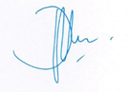
dr. Wiwiek Probowati, Sp.PD,KHOM-FINASIM dr. Tejo Jayadi Sp.PA

Author 3 Author 4
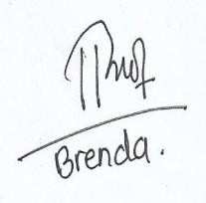
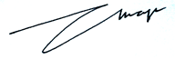

Brenda Miriane Rustam Agatha Maheswari Adita Putri

