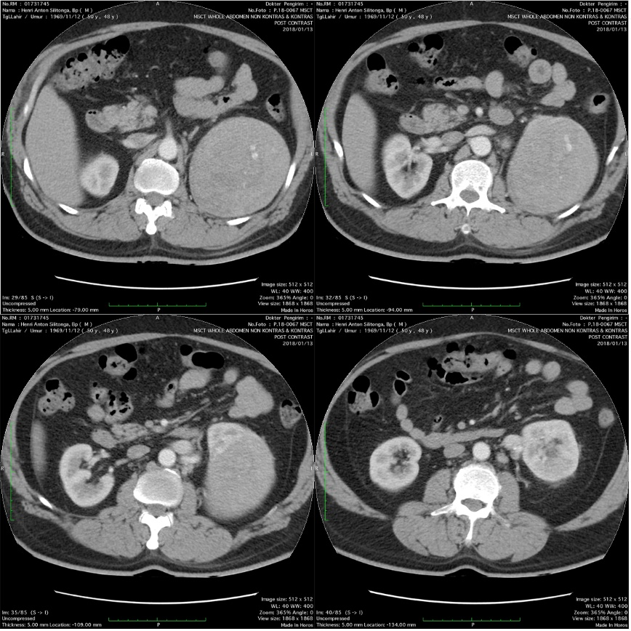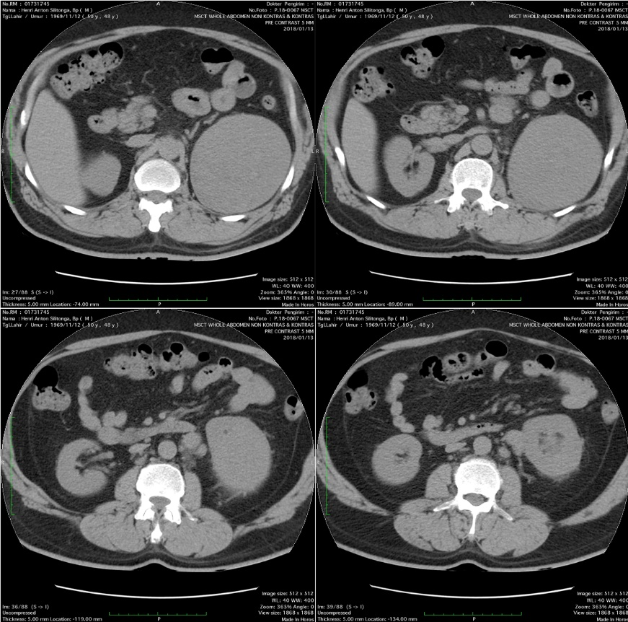

**Figure 1: MSCT images of left renal angiomyolipoma (pre-contrast)**

**Figure 2: MSCT images of left renal angiomyolipoma (post intravenous contrast)**

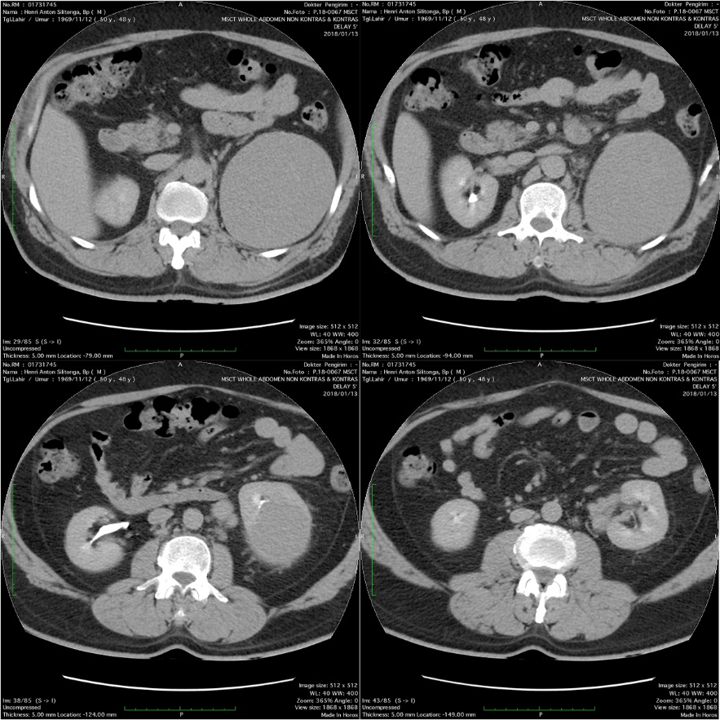

**Figure 3: MSCT images of left renal angiomyolipoma (delayed contrast 5 minutes)**